THEATRE ROYAL DRURY LANE ACCESS INFORMATION

Access & Relaxed Performances
Signed Performance
Sunday 18 June 2023
5:30pm
Audio Described
Sunday 30 July 2023
5:30pm
Captioned Performance
Sunday 20 August 2023
5:30pm
Relaxed Performance
Sunday 3 September 2023
1:00pm

Welcome to the Access Information page for Theatre Royal Drury Lane.

Venue Address & Contact Details:
Address:
Theatre Royal Drury Lane
Catherine Street
London
WC2B 5JF

Telephone:
020 3925 2998

LW Theatres is dedicated to understanding the potential access requirements of all people visiting and working in our venues. Our commitment to improving accessibility is long term and extends across all areas of our business. We recognise our responsibility to identify barriers to accessibility and undertake to remove these wherever possible.

LW Theatres’ Access Scheme
Customers with Access requirements will be able to purchase a ticket in the price band of their choice, subject to availability.
One additional companion ticket will be made available at the same price paid by the customer with Access requirements, subject to availability. Any additional tickets required in the suitable area will be chargeable at the standard admission rate.

Exchanges and Refunds
Customers who notify LW Theatres, at least 2 hours in advance of their booked performance, that they are unable to attend due to a reason directly related to their access requirements will be able to either exchange their tickets to another performance or offered a refund. Refunds will be limited to the face value of the ticket, excluding any booking fees and cannot be issued once the performance has begun.

How to book:
To enquire about purchasing Access and Personal Assistant tickets for shows at Theatre Royal Drury Lane, please email access@lwtheatres.co.uk

The Ticket Desk will be located in the foyer and has step-free access via the entrance on Russell Street.

Arrival
There are 4 steps into the foyer from the main entrance on Catherine Street.
There is step free access via the entrance on Russell Street.
If customers find they require any assistance or further information, please do not hesitate to speak to a member of the guest experience team who will be happy help.
Our closest tube stations are Holborn (Central & Picadilly Line), Covent Garden (Picadilly Line), Temple (Circle & District Line) & Charing Cross (Northern, Bakerloo & National Rail).
Our closest step-free tube stations are Tottenham Court Road (Central, Elizabeth & Northern Line) and Blackfriars (Circle, District & National Rail).
For more information on the closest Blue Badge parking bays, you can find a full list here: https://www.westminster.gov.uk/parking/disabled-parking/where-you-can-park-disabled-badge

Access to Seating and Viewing Areas:
A passenger lift is available to all 4 levels with non-transferable wheelchair spaces available on all levels except for the Balcony.
Stalls – There are 10 steps to access the Stalls from Catherine Street, but there are no further steps once inside the auditorium.
Level access is available from both the Russell St entrance and from the foyer.
Level Access ramps from the foyer will lead to the sides of row M providing easy access for wheelchair users.
We have 4 non-transferable wheelchair spaces in the Stalls, available in the side sections of rows M in M12; M16; M36 and M39.
Transferrable Wheelchair positions are situated in row C17, C33 and C34, but any inside aisle seats are also suitable.
Royal Circle – There are 39 steps to reach the rear of the level.
Level Access from the passenger lift is available to row L (low numbers side).
There are two steps between each row with hand rails available on the far left and right aisles only.
We have 1 non-transferable wheelchair space available in K9.
Grand Circle – There are 66 steps from ground floor level.
Level Access from the passenger lift is available to row E (low numbers side) or 2/3 steps down/up to rows D/F.
We have 1 non-transferable wheelchair space available in E7.
Balcony – There are 112 steps up from ground floor level.
The passenger lift will take you to the front of the level where there are then 2 steps up to row B.
There is no level access.

Accessible Toilets:
Theatre Royal Drury Lane has accessible toilets available on 3 of the 4 levels.
STALLS - Accessible toilet facilities are available on both sides of the auditorium, leading off from row M.
ROYAL CIRCLE - Accessible toilet facilities are available on both sides of the auditorium, leading off from row L.
GRAND CIRCLE - Accessible toilet facilities are available on the right hand side of the auditorium, leading off from row E (low numbers).

Access to Performance:
Our trained access hosts will be available to assist visually impaired customers upon arrival and throughout their visit if required.
We will be working with accessibility service provider GalaPro to deliver audio enhancement via the user’s own mobile device and ear phones. Additionally, in conjunction with Frozen, the following services will soon be available:
- Closed captions
- Audio description
- Multilingual subtitles
- Dubbing

To access these services please download the GalaPro App using the link above. Customers who do not own a compatible mobile device should speak to a member of the guest experience team on arrival who will be able to assist.
In conjunction with the Producer of each show, Theatre Royal Drury Lane hosts periodic accessible performances, including Audio-described, Captioned, BSL Interpreted and Relaxed performances.

Medical Requirements:
If you need to bring medication, food or drink to manage a medical condition, or medical equipment you are welcome to do so. Please ask to speak to a manager when you arrive before going through our security searches.
Please note, we are not in possession of any medical equipment.

Assistance Dogs:
Assistance dogs are welcome in Theatre Royal Drury Lane. Our staff are always happy to look after your access dog for you whilst you enjoy your visit.

Strobe and Lighting Effects
FROZEN - Please be advised that smoke, haze and strobe lights are used during the performance.
Strobe and flashing lights may be used for other productions at Theatre Royal Drury Lane.
Sensory Synopsis link

Evacuation Policy
Our access hosts are trained in how to assist customers with access requirements in case of an emergency. These staff members will be specifically allocated to assist any customers with access requirements in an emergency situation.

Services and Facilities:
The Disney Gift Shop is located at the far end of the Foyer and is accessible from the step free Russell Street entrance.
The Cecil Beaton Bar is also at one end of the foyer and will be open throughout the day for full bar refreshments including teas and coffee.
Ticket facilities are located in front of the Gift Shop.
The Grand Saloon Bar will also have afternoon teas available during the day and is accessible from the Royal Circle level passenger lift.
Full details of all food and beverage offerings and how to book please click the link https://thelane.co.uk/eat-and-drink

The Rotunda will have a champagne bar available at show times and there are 2 steps to take you there from the foyer.
The Ivor Novello Terrace is accessible from the Grand Saloon Bar.
Cloakroom facilities are available via the Prince’s Gallery. £1.50 per item.

- The image next to the Arrival information should probably be changed. The other venues have a car instead of a wheelchair. 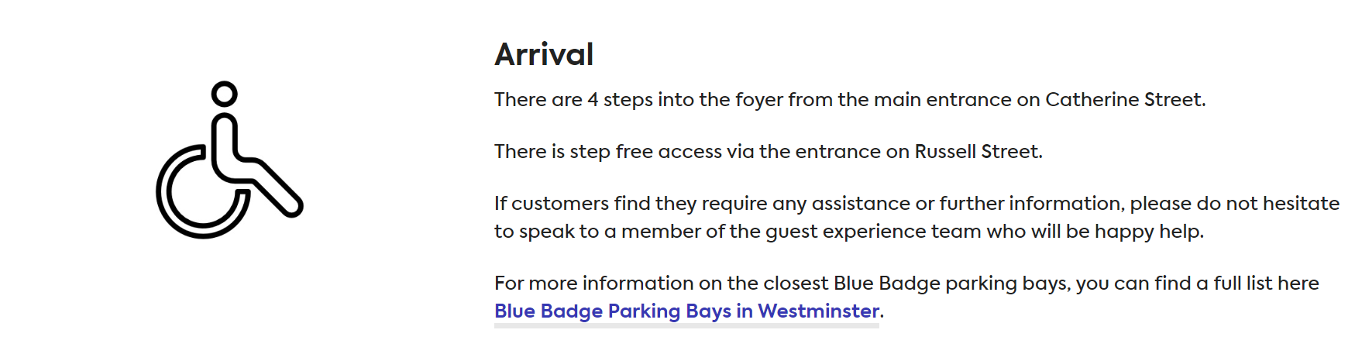

- The visual story is very hard to find on the site. Maybe we should have a link for this. The story also needs updating as it is very COVID heavy and may confuse people.

- The Palladium also has a section for feedback at the bottom of the page, which might be a great addition.

