# HIS MAJESTY’S THEATRE ACCESS INFORMATION

## Venue Address & Contact Details:

His Majesty’s Theatre Haymarket, London SW1Y 4QL

**Telephone:**

|  |
| --- |
| [020 7850 8750](tel:020%207850%208750) |

**LW Theatres** is dedicated to understanding the potential access requirements of all people visiting and working in our venues. Our commitment to improving accessibility is long term and extends across all areas of our business. We recognise our responsibility to identify barriers to accessibility and undertake to remove these wherever possible.

# LW Theatres’ Access Scheme

Customers with Access requirements will be able to purchase a ticket in the price band of their choice, subject to availability.

One additional companion ticket will be made available at the same price paid by the customer with Access requirements, subject to availability. Any additional tickets required in the suitable area will be chargeable at the standard admission rate.

Please head to our website or to one of our Box Offices to find out more about joining our Access scheme.

# Exchanges and Refunds

Customers who notify LW Theatres, at least 2 hours in advance of their booked performance, that they are unable to attend due to a reason directly related to their access requirements will be able to either exchange their tickets to another performance or offered a refund. Refunds will be limited to the face value of the ticket, excluding any booking fees and cannot be issued once the performance has begun.

## How to book:

To enquire about purchasing Access and Personal Assistant tickets for shows at Her Majesty’s Theatre, please call our Access Booking Line on **020 7087 7966**.

This service is operated by SEE Tickets. Alternatively, please email [access@lwtheatres.co.uk](mailto:access@lwtheatres.co.uk)

Tickets can also be purchased in person from His Majesty’s Theatre. The Box Office is located in the foyer and has step-free access via the main entrance on Haymarket.

**Non-transferable Wheelchair Seats**

We have space for 3 wheelchairs in the Stalls Auditorium. These are in Row E, J and M. They can all be accessed using our step free entrance on Charles II Street.

If you are a member of the LW Access Scheme as a wheelchair user, they would appear as the below seats on the seating chart when buying tickets online (see image below). If you are **not** a member of the scheme and would like one of these seats, you would need to visit the Box Office or call the Access Booking Line to buy your tickets.

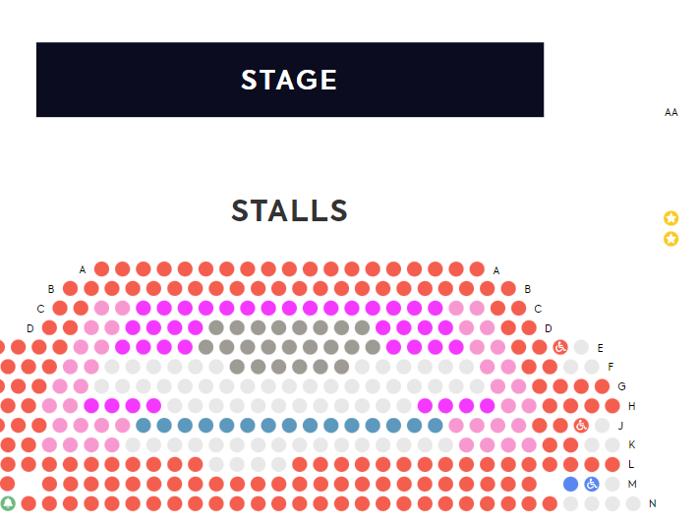



When you click on the seats, they’ll be added to your basket, and you will be prompted to confirm the price types as shown below:

**Transferable Wheelchair Seats**

All of the first seats in the Stalls from row A to row T offer a step-free access, with the option to transfer into a seat. All of these seats have access to a step-free, accessible toilet.

Please note: Online, these seats do not show as E1, the first seat in row E is E6, however, this is the first seat in the row.

*Image shown – Wheelchair space in row E of the Stalls auditorium.*

*Please note, this is not the view of the stage.*

**View from E6 – Stalls Auditorium**

*Picture of the Stage from the point of view of the wheelchair space in Row E.*

**View from J6 – Stalls Auditorium**

*Picture of the Stage from the point of view of the wheelchair space in Row J.*

**View from M6 – Stalls Auditorium**

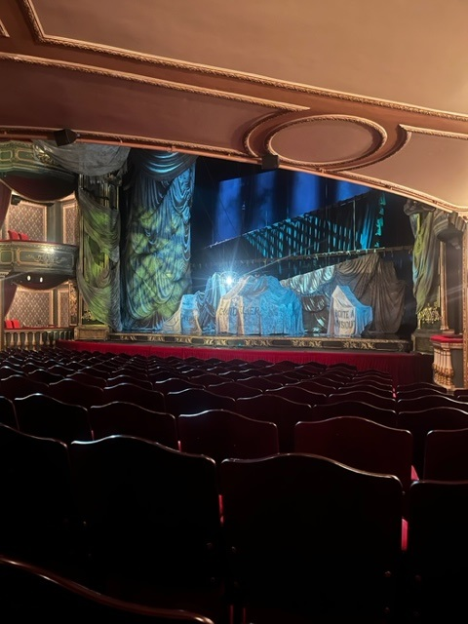

*Picture of the Stage from the point of view of the wheelchair space in Row M.*

## Getting to His Majesty’s Theatre:

Customers with access requirements can be dropped directly in front of the theatre on Haymarket where they can access the main entrance and foyer. The closest drop off point to our level access entrance is to the side of the Theatre on Charles II Street.

There are also four Blue Badge parking bays opposite the Theatre on the other side of Charles II Street.

There is a Q park car parking facility on Whitcombe Street.

You can book and pay for your parking online via the following link:

[**https://www.q-park.co.uk/en-gb/cities/london/society-of-london-theatre/**](https://urldefense.proofpoint.com/v2/url?u=https-3A__www.q-2Dpark.co.uk_en-2Dgb_cities_london_society-2Dof-2Dlondon-2Dtheatre_&d=DwMFAg&c=euGZstcaTDllvimEN8b7jXrwqOf-v5A_CdpgnVfiiMM&r=mpjgaxB0QccPc2Vf--nnOuklLvsq0_qooKGOFuesvV4&m=Gujgai3HcD9LLCdG2T66EThT_G0dT1zCyZVO0cwiAh4&s=eosPOBh4bCl2gb7ihFcmpYGDAw_IOVrPXoqz1IYJCzs&e=)

**Travelling by Public Transport**

The nearest station with step-free access is Green Park which is approximately 1km away from the Theatre.

**HAYMARKET**

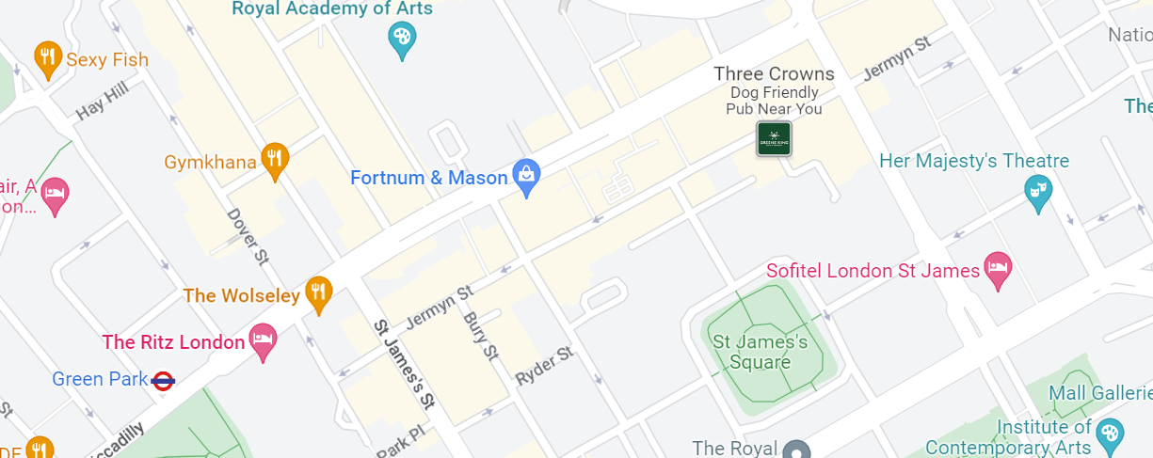

Please visit [https://tfl.gov.uk](https://tfl.gov.uk/) for further information on public transport in London.

## Piccadilly Circus is the closest TFL London Underground Station located approximately 250 metres north up Lower Regent Street, however, this station does not have step-free access.

## Arrival:

The main entrance to His Majesty’s Theatre provides level access to the Box Office, Merchandise Kiosk and Champagne Bar. Customers wishing to access any of these services should introduce themselves to the Welcome Hosts on the front doors who will assist the customer through to these facilities.

*Image of the Foyer Kiosk & Champagne bar Image of the Box Office, located in the Foyer.*

On arrival make yourself known to any member of the His Majesty’s Theatre team and a Welcome Host will greet you and assist you throughout your visit. They will show you to your seats and the toilet facilitates, provide remote access to our bar and merchandise and escort you out of the theatre at the end of the performance.

*An image of the front of His Majesty’s Theatre with members of the Welcome Host Team*

## Access to Seating and Viewing Areas

Entry into the Stalls auditorium for those who require level access is via an alternative entrance on Charles II Street.

The step free access into the Stalls is on a slight gradient and the floor is uneven in places.

We will happily store any wheelchairs, scooters, or walkers away from your seats and bring to you for the interval and the outgoing.

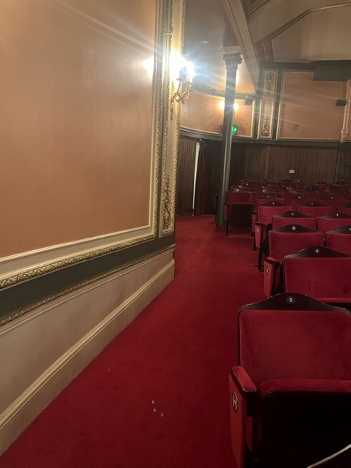

*An image of the aisle that leads from the Access entrance/Toilet to Stalls auditorium.*

The Royal Circle, Grand Circle and Balcony levels of the auditorium can only be accessed via routes including stairs:

Royal Circle - 32 steps from Ground Floor Grand Circle - 63 steps from Ground Floor Balcony - 90 steps from Ground Floor

The Royal Circle, Grand Circle and Balcony levels of the auditorium can only be accessed via routes including stairs. We do not recommend these levels for those with limited mobility due to the number of stairs.

## Accessible Toilets:

His Majesty’s Theatre has one accessible toilet located directly inside the level access entrance and close to the Stalls auditorium.

There are further standard toilets located inside the Stalls auditorium. There are Ladies toilets which have step-free access, and a unisex toilet that has 3 steps. The Gents can be accessed via 18 steps.

## A picture containing red, several Description automatically generatedLeg Room:

## There is excellent leg room in Row P in the Stalls auditorium.

## There is limited leg room in the Balcony.

## 

## Image of Row P in the Stalls Auditorium.

## Visual Requirements:

Our trained Welcome hosts will be available to assist visually impaired customers upon arrival and throughout their visit if required.

We recommend seats in the front section of the Stalls to anyone who is partially sighted.

## Audio Requirements:

Our “Sennheiser” audio enhancement system is available for deaf or hearing-impaired guests. Headsets and hearing aid loops are available and should be requested from a member of Front of House staff upon arrival.

Please inform us of this requirement when booking your tickets to ensure we have the equipment ready for your arrival.

You are more than welcome to use your own headphones with the system, if they connect with an aux cable, as seen in the image below.

Return to any member of the team before you leave the theatre.

*Image of Sennheiser audio enhancement pack and headphones*

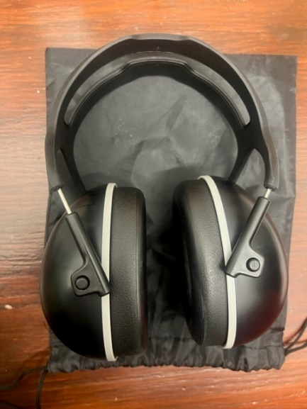We also have both over the head ear defenders and traditional earplugs available for anyone who is finding the show is too loud. You can request these from any member of staff.

## Breakout Space

## We have a breakout space in the stalls bar area that offers privacy and quiet away from the busy theatre environment. This space is great for anyone who might find the show/crowded spaces overstimulating and need some time away.

## It is a multi-purpose space for guests for a variety of health reasons both mental and physical.

## There are 22 steps from the Foyer to the breakout space.

## If you need a breakout space with step free access, please speak to a member of staff.

## Medical Requirements:

If you need to bring medication, food or drink to manage a medical condition, or medical equipment you are welcome to do so. Please ask to speak to a manager when you arrive before going through our security searches.

*Please note, we are not in possession of any medical equipment.*

## Assistance Dogs:

Assistance dogs are welcome in His Majesty’s Theatre. Our staff are always happy to look after your access dog for you whilst you enjoy your visit.

## Evacuation Policy

Our Welcome Hosts are trained in how to assist customers with access requirements in case of an emergency. These staff members will be specifically allocated to assist any customers with access requirements in an emergency situation.

***Services and Facilities:***

There is a cloakroom available. Items can be checked in for £1.00 each.

Our staff are on hand throughout your visit to assist with any purchases you may wish to make. If you are unable to access the bars or kiosks, then please speak to our access host upon arrival who will be happy to assist you.

***Strobe/Lighting Effects, Loud noises and potentional triggers:***

This show contains loud sounds, gun shots, flashing lights, haze, fire, pyrotechnics and depictions of violence and death at certain points during the performance of Phantom of the Opera.

For the performance of Phantom of the Opera, the Welcome Hosts can be on hand in the auditorium, ahead of these moments to warn you, if you are sat on the aisle. Alternatively, we can provide a document with them on in advance.

For more information about anything access related at His Majesty’s Theatre, please call our Stage Door on 020 7850 8750 and ask to speak to a manager.